A PROJECT REPORT
On
IT Ticket Optimization Using Machine Learning
Submitted in partial fulfillment of the
requirements for the degree of
BACHELOR OF TECHNOLOGY
In
Information and Communication Technology

Submitted by
116014063-R. Meena Priyadharshini



Under the Guidance of
Meghana Kawari
Lead Applications Developer, IT - Apps COLT
April 2016










Acknowledgement
I would forever remain grateful tohonorable Prof. R. Sethuraman, Vice Chancellor for his encouragement in my academic life at SASTRA University.
I wish to express my profound gratitude toDr. S. Vaidhyasubramaniam, Dean - Planning & Development, Dr. S. Swaminathan, Director CeNTAB and Prof. G. Bhalachandran, Registrar for their overwhelming support provided during my course span in SASTRA University.
I am extremely thankful to Dr. P. Swaminathan, Dean School of Computing and Dr. K.S. Ravichandran, Associate Dean, Department of Information and Communication Technology for providing me the opportunity to do this project and for all the academic help extended in my project.
I sincerely express my gratitude to my manager Mr. Rohan Chaudhury, VMWARE SOFTWARE INDIA PVT LTD for his assistance and guidance for the successful implementation of project in a systematic and professional manner. I also express my gratitude to my mentor Mrs. Meghana Kawari, VMWARE SOFTWARE INDIA PVT LTD for always guiding me in the right direction to complete my project.
I also thank all the Teaching and Non-teaching staff, and those who have directly or indirectly helped me by extending their moral support and encouragement for completion of this project.
I thank God Almighty and my parents for helping me procure such a challenging and interesting project, and in completing the same in due course without much difficulty.

SYNOPSIS

VMware has a large footprint of enterprise applications which are critical to keep VMware operational and competitive. This complex ecosystem is sustained by a global team of IT resources with a mandate to keep the lights on and keep the landscape operational. VMware’s IT support team is looking at ways to evolve from a reactive and capacity constrained organization to a proactive/instant and scalable support organization. As a part of this larger initiative, IT wants to leverage machine learning to evolve patterns based on production data intelligence and use the derived learning as feedback to build self-healing solutions that can act as the first layer of support.IT also wants to use machine learning to augment the understanding of VMware’s support landscape – profile support demand, identify skill exposure, predict escalations etc.
VMWare IT develops and supports multiple applications. Approximately 34000 tickets raised annually; 600 on an average are unresolved in 6 months. The existing system has the following limitations:
- Handoffs: Multiple application experts
- Reactive and slow.
- Capacity constrained
- Global Team Management
This model tries to improve Customer Satisfaction & Business Efficiency.
The system aims to prevent cases from getting escalated in order to meet customer needs immediately. The process of implementing such a system involves training the historical data set using machine learning algorithms to identify the patterns and building the network model. The model will be efficient to predict the likelihood of cases being escalated for the new set of unseen data feed.

TABLE OF CONTENTS
Chapter No. | TITLE | Page Number
1. | Introduction | 1
2. | Literature Review | 4
3. | Software Project Plan | 8
4. | System Configurations | 18
5. | System Analysis and Design | 19
6. | Sample Code | 20
7. | Testing | 32
8. | Implementation | 33
9. | Output Snapshots | 34
10. | Conclusion | 50
11. | References | 51

CHAPTER -01
INTRODUCTION
1.1 INTRODUCTION TO THE COMPANY – VMWARE
1.1.1 INTRODUCTION
VMware is the industry-leading virtualization software company. VMware Inc. is a subsidiary of EMC Corporation. VMware Inc. has its headquarters in Palo Alto, California. VMware is the industry- leading virtualization software company. Their technologies
simplify IT complexity and streamline operations, helping businesses become more agile,
efficient and profitable. By virtualizing infrastructure—from the data center to the cloud to
mobile devices—we enable IT to deliver services from any device, anytime, anywhere.
1.1.2 FOUNDERS
VMware was founded by Diane Greene, Mendel Rosenblum, Scott Devine, Edward Wang and Edouard Bugnion. Edouard Bugnion remained the chief architect and CTO of the company until 2005. On July 8,2008 VMware co-founder, president and CEO Diane Greene was replaced by Paul Maritz, a retired 14-year Microsoft veteran who was heading EMC’s cloud computing business unit.
1.1.3 A BRIEF HISTORY
VMware is a Palo Alto, California based company founded in 1998. The first product VMware Workstation was delivered in May 1999. VMware entered the server market in 2001 with VMware GSX Server and VMware ESX Server. It was acquired by EMC Corporation in 2004 and on August 14, 2007 EMC sold 15% of the company in a New York Stock Exchange IPO. The company trades under the symbol VMW.
On September 16,2008, VMware announced its collaboration with Cisco to provide joint data center solutions.

1.2 BACKGROUND OF THE PROJECT
1.2.1 OBJECTIVE
This project aims to improve the support offered to VMware customers by providing immediate response to tickets (support issue) raised. In other words, the aim is to reduce escalation by using system and application logs to automate the support process. Such an initiative involves usage of learning methods to evolve patterns based on production data intelligence.
1.2.2 EXISTING SYSTEM AND LIMITATIONS
The support system that is currently being used is highly manual. A customer reports an issue by raising a ticket. IT creates and manages applications related to:
- EDW Loads
- Integrations Between Systems
- FMW (Fusion Middleware)
- Portal (myvmware.com. other portals).
Tickets raised concerning the above might get delayed due to human errors. This might affect the product sale and efficiency. Thus an unresolved ticket gets escalated.
Escalation might be due to
- Severity of issue
- Time taken to resolve
In a manual support system, a ticket raised has to reach the team concerned after which the ticket can be resolved. This can also increase the time taken to resolve, thereby having the customer escalate the case.

The existing support system faces the following challenges:
Handoffs: It has Globally distributed teams. It requires multiple application experts.
Reactive and slow: It involves many manual steps that are prone to numerous human errors.
Capacity constrained: Building team for every technology monitoring/action is tedious and difficult to organize and maintain.

1.2.3 PROPOSED SYSTEM
The major goal is to train a model using historical data which involves the use of neural networks and to predict the likelihood of cases being escalated for the new set of unseen data feed using the trained model. The goal is to create two models. Given a set of features the first model has to predict the chances of a case getting escalated which helps the system to assign priorities to cases. Cases might get escalated when the time taken to resolve the case is large. The second model has to predict the risk of it being escalated by taking in the resolution time as the criteria for prediction. The trained models are developed with historical support data and they are validated using real time data feed. The predicted results are reported using charts that makes it easy to visualize and draw conclusions. Also, the result is downloaded as file along with the input features that led to the conclusion for future reference. Thus the manual intervention is reduced.

2.LITERATURE REVIEW
2.1 JAVA
Java is one of most popular computer programming language that is concurrent, class-based and object oriented. A compiled java code can run on any java supported platform without requiring any recompilation. It has five primary principles:
- It is simple and object oriented.
- It is robust and secure.
- It is architecture-neutral and portable.
- It executes with high performance.
- It is threaded and dynamic.

2.2 ENCOG FRAMEWORK
Encog is an advanced machine learning framework that is available for Java, C# and C++. It has been in active development since 2008. It supports a variety of algorithms such as Support Vector Machines, Artificial Neural Networks, Genetic Programming, Bayesian Networks, Hidden Markov Models, Genetic Programming and Genetic Algorithms. However most of its strength lies in neural networks. It also contains a GUI workbench. This project uses Encog Java. The Encog jar files are included in eclipse project for the model development. The model that was developed using Encog is based on “Resilient Propagation” neural network.
2.3 NEURAL NETWORK
Artificial neural networks are largely mathematical constructs that were inspired by biological neural networks.
Input
Layer
Hidden
Layer
Output
Layer
(input pattern) ------- ------ ------ -------(output pattern)

2.3.1 NEURAL NETWORK STRUCTURE
A typical neural network has three layers.
    - Input is presented to Input Layer
    - Output is derived from the Output Layer
    - What happens between input and output layer is a black box (Hidden Layer).
2.4 SPRING
The Spring Framework is a lightweight framework which can be thought of as a “framework of frameworks because of its ability to support various frameworks. The framework is open source. Spring has the following advantages:
- Lightweight
- Fast Development
- Powerful abstraction
- Declarative support
- Predefined Templates
- Loose Coupling
- Easy to test
An important feature of Spring Framework is Dependency Injection. Dependency injection is defined as a software pattern that allows the removal of the hard-coded dependencies and makes it possible to change them, whether at the runtime or at the time of compiling.

2.5 SPRING MVC
The Spring MVC framework can be used to create flexible web applications. It provides model-view-controller and other readymade components for ease of use.
The model is used to encapsulate the application data.
The view is responsible for rendering the model data. In other words, it generates HTML output that is interpreted in the browser window of the client.
The Controller takes the responsibility of processing the requests of user and building a model that is appropriate. It passes the model to the view for rendering.

2.5.1 THE DISPATCHER SERVLET
The Spring MVC is built around a Dispatcher Servlet that is used to handle all the HTTP requests and replies.

HTTP Request HTTP Response
Dispatcher Servlet

1.Handler Mapping
3.View Resolver
2.Controller
4.View

- Once a request has been received the Dispatcher Servlet Consults Handler Mapping to make a call to the appropriate Controller
- The controller takes in the request and make calls to appropriate service methods. The service method will return the name of the view to the Dispatcher Servlet.
- The Dispatcher Servlet takes the help of ViewResolver to grasp the view that is defined for the request.
- Finally, Dispatcher Servlet passes the data of the model to the view. This view is rendered on the browser window.

2.6 TABLEAU
Tableau is a business intelligence software that lets the users to easily connect to data, then visualize and create interactive dashboards. Tableau offers five main products:
- Tableau Desktop
- Tableau Server
- Tableau Public
- Tableau Online
- Tableau Reader
The data source is loaded on to Tableau Server and the data is refreshed using Online Sync Client. The resultant report is presented in the form of “Donut Chart”.

2.7 XML
XML stands for Extensible Markup Language that stores and transports data. It was designed in a way to be both human readable and machine readable.

2.8 JAVASCRIPT
JavaScript is a lightweight programming language which is used to create network-centric applications. It is complimentary to Java programming language. It is open and cross-platform.

2.9 JSP
Java Server Pages is a server-side programming technology. It enables the creation of dynamic Web-based applications that are also platform-independent.
The Java Server Pages Standard Tag Library (JSTL) is a collection of useful JSP tags which hold together the core functionality common to many JSP applications.
JSTL has support for common applications such as formatting, database access, iterating, manipulating XML documents, structural tasks such as iteration and conditionals, tags for manipulating XML documents, internationalization tags, and SQL tags. It also provides a framework for integrating existing custom tags with JSTL tags.

CHAPTER -03
SOFTWARE PROJECT PLAN
The first step involves studying and understanding the ticket raising data (support data) before developing a model. Both the model discussed here had different properties and hence uses two different propagation algorithms. Noise and redundant data were present. Hence data preprocessing was mandatory.

3.1 USECASE 1: ESCALATION PREDICTION- SEVERITY
This model involves predicting the chance of a case getting escalated based on the following input features:
- A Unique Case Number
- Name of the Customer
- Support Group Bucket
- Line of Business Bucket
- Date Opened and Closed
- IT_Track
- Component
- Sub-Component
- Category
- Sub-Category
- Reported by Profile
- Reported by Division
Historical Data with the above mentioned features were given as input to the network to develop a model after which test/real time data was fed to the model to verify and validate the model. The result(prediction) has got two classes namely
Class 1: Yes
Class 2: No
The model was trained using a data set that contained the class column. It was examined using real time data without the class to test its efficiency and accuracy.

3.2 USECASE 2: RESOLUTION PREDICTION
This model involves prediction of the risk of a case getting escalated based on the resolution days. The input features that this model takes into account are:
- A Unique Case Number
- Date opened
- IT_Track
- Support Group Bucket
- Line of Business Bucket
- Category
- Sub Category
- Component
- Sub Component
Developing a model involved taking historical data set and finding the resolution days
Resolution days=Date Opened- Date Closed
The model contains three classes
Class 1: Low with resolution days between 0-3 days
Class 2: Medium with resolution days between 4-6 days
Class 3: High with resolution days between 7-9 days
The test/real time data does not have information about resolution days and contains only the Date Opened data and not Date Closed data. Hence the model predicts the risk range in which each case lies based on the data intelligence it gained from training it using the historical data.

The development of a model in Encog is divided into five steps:
3.3 STEPS

3.3.1 SHUFFLE
The input data is given to Encog functionality where as a first step Encog shuffles the given data set before the actual processing begins. Shuffling can be done using Encog’s inbuilt utility.

3.3.2 NORMALIZATION
Neural Networks are very intelligent but they cannot process just any kind of data. Often the data must be normalized. Neural Networks are designed to accept floating point numbers as input. There are two broad classes of data to normalize:
    - Numeric class
    - Non- Numeric class
These two data classes each have techniques for normalization.
Numeric data is normalized by mapping values to a specific range, often
from -1 to +1. Another common range is between 0 and +1.
Non-numeric data is usually an attribute that defines a class. To normalize these classes, they must be converted to an array of floating point values, just as
with numeric data.
Encog supports two types of nominal normalization. The first is called
“one-of-n.” One-of-n creates a number of neurons equal to the number of class
items. The class number to be encoded is given a value of 1. Others are given
zeros.
Equilateral encoding is another way to encode a class. For equilateral
encoding, a number of neurons is used that equals one, less the number of
class items. A code of floating point numbers is created for each class item
with uniform equilateral distance to the other class data items. This allows all
output neurons to play a part in each class item and causes an error to affect
more neurons than one-of-n encoding.

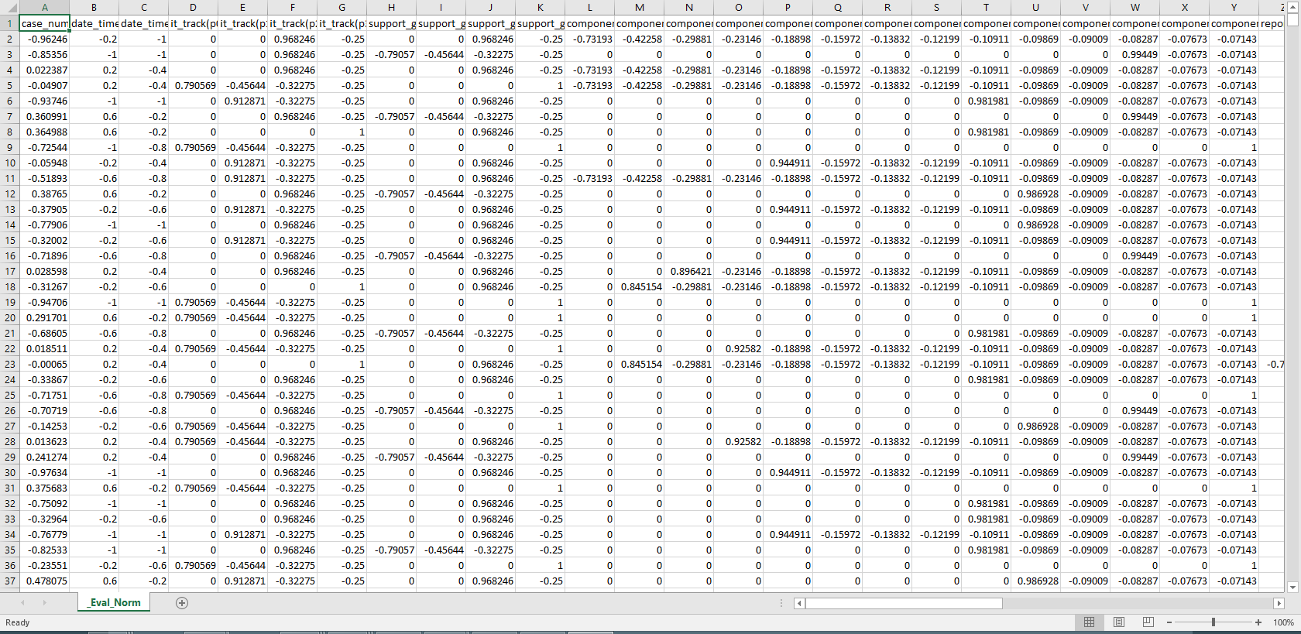

3.3.3 CREATING A NEURAL NETWORK
A neural network refers to a system that consists of interconnected neurons. Two or more neurons in a network may or may not exchange messages between them. Neurons that exchange information are said to be connected. The input layer is connected to the hidden layer and the hidden layer is connected to the output later by means of interconnection weights. These weights are numerical and are tuned and adjusted as the machine learns. The greater the number of hidden layers in a network the greater is the computational complexity of the neural network.

THE ROLE OF ACTIVATION FUNCTIONS
Activation Functions play a very important role in training neural networks. They are used to scale the output from layers .
ACTIVATION LINEAR
Linear activation does not perform any activation at all. It is mostly used for input layers where no activation is required. It implements the linear function:
f(x)=x


ACTIVATION TANH
The ActivationTANH uses hyperbolic tangent function. It is the default and most commonly used activation function for Encog.
f(x) = e2x – 1/e2x + 1

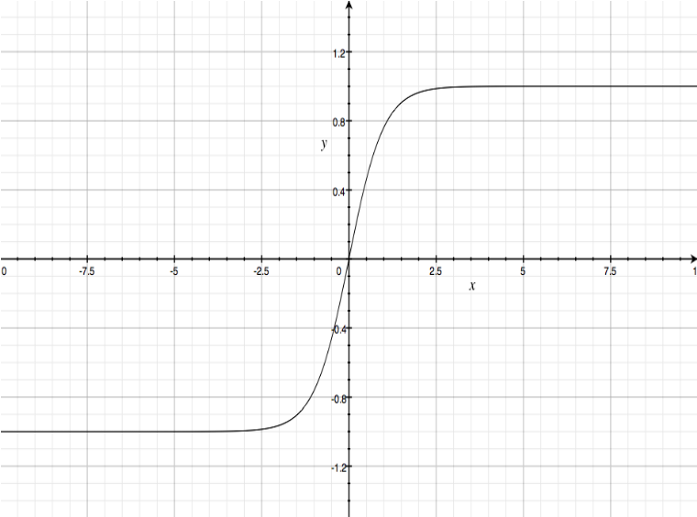

3.3.4 TRAIN A NEURAL NETWORK
Training can be defined as the means in which the neural network weights are adjusted to produce desirable outputs. The propagation training algorithm will go through a series of iterations that will improve the neural network’s error rate by some degree. The error rate is the percent difference between the actual output from the neural network and the ideal output which is provided by the training data. Each iteration will completely loop through the training set. For each item of the data, certain changes to the weight matrix will be calculated. These changes will be applied in batches using Encog’s batch training. Thus the Encog updates the weight matrix values at the end of each iteration.
RESILIENT PROPAGATION
A Resilient Propagation is an algorithm that is used to train a neural network. It is similar to back propagation except that it does not require any additional parameters and is faster than back propagation.

RPROP - WEIGHT-STEP RULE
Each weight has an individual evolving update value. The weight-step is only determined by its update-value and the sign of the gradient.

∆ w_{ij} (t)= +∆_{ij}(t), if ∂E /∂wij (t) > 0
−∆_{ij} (t), if ∂E ∂wij (t) < 0
0, Otherwise

RPROP - LEARNING RULE
∆ij (t)=
η+ ⋅ ∆_{ij} (t − 1), if sij > 0
η− ⋅ ∆_{ij} (t − 1), if sij < 0
∆_{ij} (t − 1), otherwise

Where s_{ij} = ∂E ∂wij (t −1) ⋅ ∂E ∂wij (t).
η+ =1.2
η− = 0.5
BACK PROPAGATION
As the name implies, back propagation algorithm propagates the errors from the output node to inner nodes. It allows quick convergence on expected local minimum for error in the network kinds to which it is most suited. The architecture of neural network resembles a multi-layered feed forward network. The algorithm of back propagation involves four stages:
INITIALIZATION OF WEIGHTS:
Random small values are assigned to connections.
FEED FORWARD:
Each input unit receives and input signal. This signal is passed on to each of the hidden units. The hidden unit sends its signal to output unit which forms the response for the given input pattern.
BACK PROPAGATION OF ERRORS:
Each output unit compares the error associated for that unit. The proportion of error contribution by each of the unit is distributed to all units in previous layer.
UPDATION OF THE WEIGHTS AND BIASES:
As and when the data passes through each unit in the connected neurons the weights are updated to reflect the learning process of the machine.
Back Propagation is relatively simple to implement and the computation time can be reduced if the weights chosen are small at the beginning.
3.3.5 EVALUATE A NEURAL NETWORK
Real time data is given as input to the trained model and model predicts if a case has chances of escalating or not. Evaluation is used to test and validate the accuracy of the model to predict when an unseen data is fed to it. The real time data is the ticket data which can be fed into the model to predict if it has chances to escalate as is in use case 1 or to predict the risk range in which the case lies based on resolution days as is in use case2. Real time data when fed yielded 82% of success rate in use case 1 and 87% of success rate in use case2. The result of prediction gets downloaded in a CSV file along with the input features.

EVALUATION RESULT FILE- ESCALATION PREDICTION
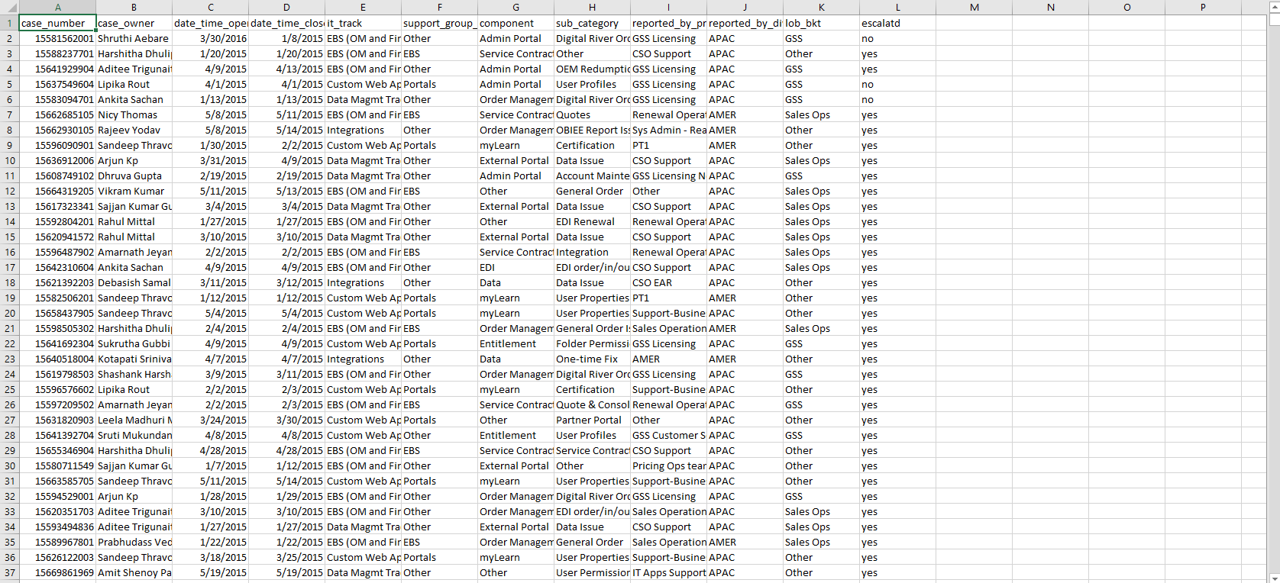

EVALUATION FILE- RESOLUTION PREDICTION
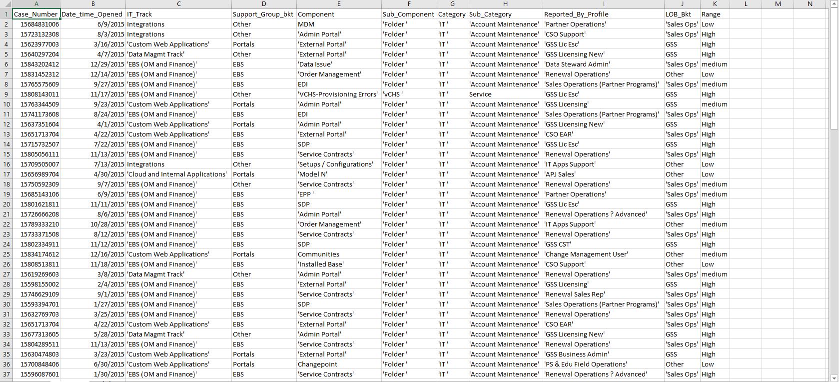

CHAPTER-04
SYSTEM CONFIGURATION

4.1 HARDWARE CONFIGURATION
Operating System: Windows 8.1 Enterprise
Installed Ram : 16 GB
Processor : Intel(R) Xeon(R) CPU E5-1620 v3 @ 3.50GHz
4.2SOFTWARE CONFIGURATION
Software Version
Encog 3.3
Apache Tomcat 7.0.68
JDK 1.7
Spring 4.2
Eclipse Indigo and Mars
Tableau 9.2

CHAPTER – 05
SYSTEM ANALYSIS AND DESIGN
5.1 SYSTEM DESIGN
System design is the process of defining the architecture, components, modules, interfaces and data for a system to satisfy the requirements specified. Systems design could see it as application of systems theory to product development. There is some overlap with the discipline of the system analysis, architecture and engineering. Conceptual design is not the end of design process. It serves as the basis for a brief design.
System design implies a systematic and rigorous approach to the design as demanded by complexity of many system problems
5.1.1 HIGH LEVEL DESIGN
UML stands for Unified Modeling Language. UML is a standard general-purpose modeling language in the field of object-oriented software engineering. In other words, it is often described as the successor of object oriented design and analysis.
The goal is for UML to become a common language for creating models of object oriented computer software. UML is just not limited to software systems but also can be used to model non software systems. The UML uses mostly graphical notations to express the design of software objects.

5.2 DATA FLOW DIAGRAM
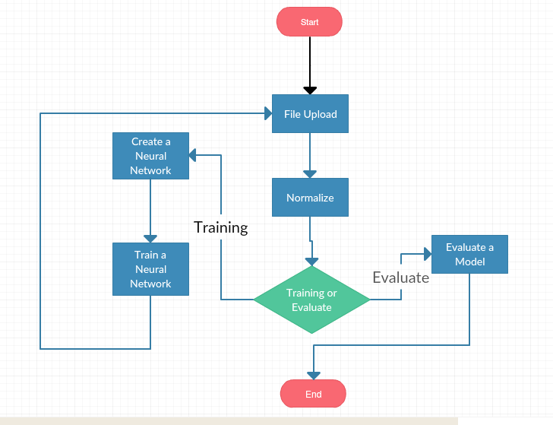

5.3 UML DIAGRAMS
5.3.1 USE CASE DIAGRAM
Use Case Diagrams are used to gather those requirements that influence the system internally and externally. They are most often requirements related to design. Therefore, when a system is studied to understand and gather its functionalities uses cases are constructed.
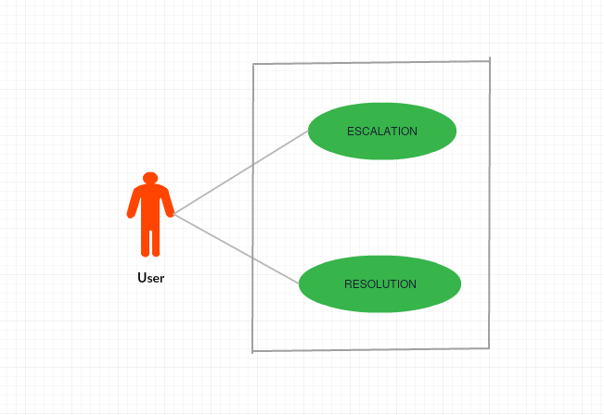
5.3.2 SEQUENCE DIAGRAMS
Sequence diagrams depict how objects within system interact with each other in various scenarios. In other words, it shows the occurrence or sequence of objects in the application. It can also be referred to as event diagrams.
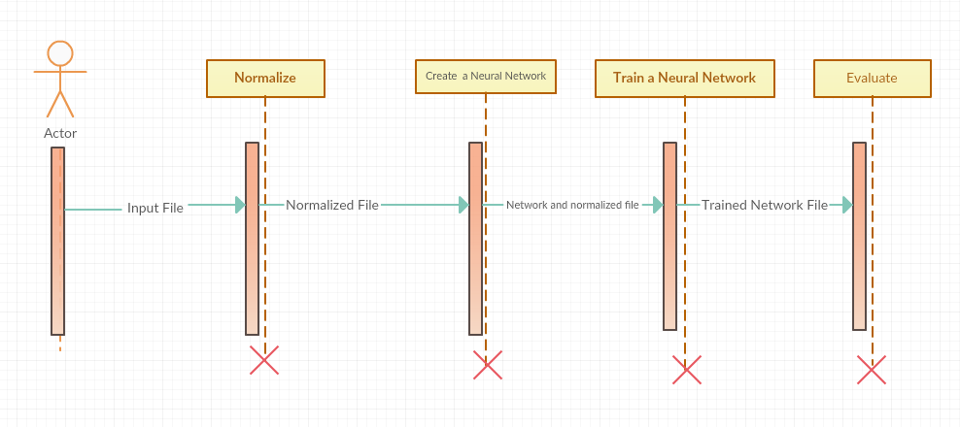
5.3.3 ACTIVITY DIAGRAM
Activity diagram represents flow from one activity to another. It represents business and operational workflows of components in a system. In other words, it shows the overall flow of control and captures the dynamic behavior of the system. They have various advantages compared to data flow diagrams which include branching, parallel flow, swimlane etc. This can leverage investigation of business requirements a later stage of development.

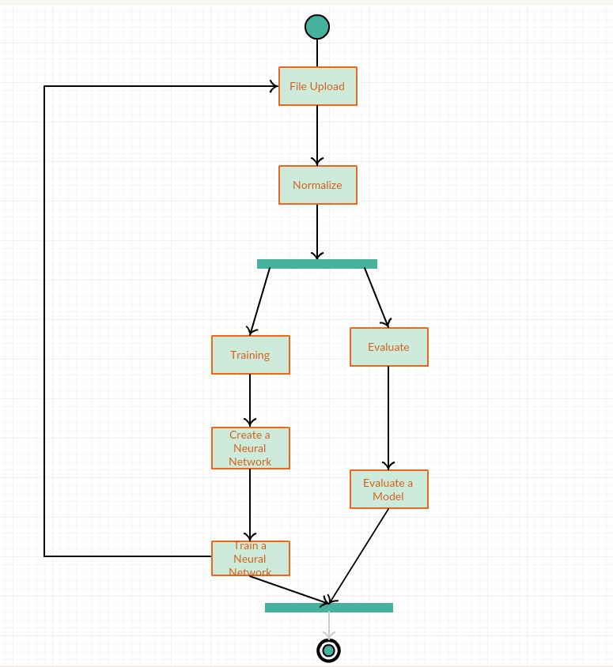

CHAPTER – 06
SAMPLE CODE
Adhering to the non – disclosure clause signed with the company, a sample source code of
a simple application, exercising the technologies used in the project used in the company code is presented in this section.

6.1 PSEUDOCODE
For each use case
{
If request is severity prediction
{this would use the model to predict if a case would get escalated}
If request is resolution prediction
{this would use the model to predict the risk range in which each case lies}
}

6.2SPRING MVC
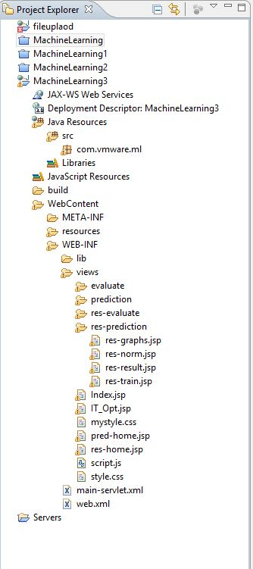
This is the project explorer image where all the code base lies in.
The “Java Resources” contains the java source files. The libraries required to run
the application is found under the Libraries section. View contains the code that the model invokes. In other words, it is the View that is rendered on the browser.

6.2.1Web.xml
<?xml version="1.0" encoding="UTF-8"?>

<web-app xmlns:xsi="http://www.w3.org/2001/XMLSchema-instance" xmlns="http://java.sun.com/xml/ns/javaee" xmlns:web="http://java.sun.com/xml/ns/javaee/web-app_2_5.xsd" xsi:schemaLocation="http://java.sun.com/xml/ns/javaee http://java.sun.com/xml/ns/javaee/web-app_3_0.xsd" id="WebApp_ID" version="3.0">

<display-name>MachineLearning</display-name>

<servlet>
<servlet-name>main</servlet-name>
<servlet-class>
org.springframework.web.servlet.DispatcherServlet
</servlet-class>
</servlet>

<servlet-mapping>
<servlet-name>main</servlet-name>
<url-pattern>/</url-pattern>
</servlet-mapping>

<welcome-file-list>
<welcome-file>IT_Opt.jsp</welcome-file>
</welcome-file-list>

</web-app>

6.2.2 main-servlet.xml
This “main-servlet.xml” will contain the details such as which packages to scan for mapping the URLs with the application, details on how to resolve a view etc. can be found here.

<?xml version="1.0" encoding="UTF-8"?>
<beans xmlns="http://www.springframework.org/schema/beans"
xmlns:xsi="http://www.w3.org/2001/XMLSchema-instance"
xmlns:mvc="http://www.springframework.org/schema/mvc"
xmlns:p="http://www.springframework.org/schema/p"
xmlns:context="http://www.springframework.org/schema/context"

xsi:schemaLocation="
http://www.springframework.org/schema/beans
http://www.springframework.org/schema/beans/spring-beans.xsd
http://www.springframework.org/schema/context
http://www.springframework.org/schema/context/spring-context.xsd
http://www.springframework.org/schema/mvc
http://www.springframework.org/schema/mvc/spring-mvc-3.0.xsd">

<context:component-scan base-package="com.vmware.ml"/>
<mvc:resources mapping="/resources/**" location="/resources/" />
<mvc:annotation-driven/>

<bean
class="org.springframework.web.servlet.mvc.annotation.DefaultAnnotationHandlerMapping">
</bean>
<bean class="org.springframework.web.servlet.view.InternalResourceViewResolver">
<property name="prefix" value="/WEB-INF/views/"/>
<property name="suffix" value=".jsp"/>
</bean>

6.3 USE CASE 1: ESCALATION PREDICTION-SEVERITY
6.3.1 SHUFFLE

ShuffleCSV shuffle = new ShuffleCSV();
shuffle.analyze(BaseFile,true,CSVFormat.ENGLISH);
shuffle.setProduceOutputHeaders(true);
shuffle.process(ShuffledBaseFile);

The above code calls the shuffling utility of Encog. The file path is given and the language of the file is set to English. “setProduceOutputHeaders” treats the first row of data as heading and reflects the same in output. The shuffling process is called then.

6.3.2 NORMALIZATION
AnalystNormalizeCSV norm = new AnalystNormalizeCSV ();
//Analyst
EncogAnalyst analyst = new EncogAnalyst ();

AnalystWizard wizard = new AnalystWizard(analyst);
//Wizard
wizard.wizard(Normalize.TrainFile, true, AnalystFileFormat.DECPNT_COMMA);

Norm.Analyze(BaseFile, true, CSVFormat.ENGLISH, analyst);

norm.setProduceOutputHeaders(true);

norm.normalize(EvalNormalizedFile);

analyst.save(AnalystevalFile);
finishFlag = true;
return finishFlag;

//Norm for Training

The AnalystNormalizeCSV extract fields from a file into a numeric array for the machine to learn. The wizard will analyze the source file and build all of the normalization stats needed to perform the normalization. Thus an object which will perform the actual normalization is created after analyzing the input file. Once the data is normalized the stats can be saved for later use.

6.2.3 CREATING A NEURAL NETWORK
A neural network refers to a system that consists of interconnected neurons. Two or more neurons in a network may or may not exchange messages between them. Neurons that exchange information are said to be connected. The connections have numerical weight that are tuned and adjusted as the machine learns.

The AnalystNormalizeCSV extract fields from a file into a numeric array for the machine to learn. The wizard will analyze the source file and build all of the normalization stats needed to perform the normalization. Thus an object which will perform the actual normalization is created after analyzing the input file. Once the data is normalized the stats can be saved for later use.
6.3.3 CREATE A NEURAL NETWORK
BasicNetwork network=new BasicNetwork();

network.addLayer(new BasicLayer (new ActivationLinear (), true, (c-2)));

network.addLayer(new BasicLayer(new ActivationTANH(), true, ((c*2)/3)));

network.getStructure().finalizeStructure();

network.reset();

EncogDirectoryPersistence.saveObject(NetworkFile,(BasicNetwork)network);

createFinishFlag = true;

return createFinishFlag;

network.addLayer(new BasicLayer(new ActivationTANH(), false, 2));

c=csv.getColumnCount();

A network can be creating using BasicNetwork objects. The above code creates a network with (c-2) input neurons where “c” is the total number of columns/features in the data including the two classes and “(c-2)” is the number of input features, “(c-2)/3” number of neurons in the hidden layer and 2 neurons in the output layer. “true” value indicates the presence of bias value. Network.reset() method is used to create a network with weights assigned between connections. The resulting network is finalized and saved.
6.3.4 TRAIN A NEURAL NETWORK
BasicNetwork network = (BasicNetwork)EncogDirectoryPersistence.loadObject(NetworkFile);

MLDataSet trainingSet = EncogUtility.loadCSV2Memory(NormalizedFile.toString(), network.getInputCount(), network.getOutputCount(),true, CSVFormat.ENGLISH,false);

Backpropagation train = new Backpropagation(network, trainingSet);

train.addStrategy(new SmartLearningRate());

train.addStrategy(new SmartMomentum());

EncogUtility.trainToError(train, 0.10);
EncogDirectoryPersistence.saveObject(TrainedNetworkFile, (BasicNetwork)network);

return true;

Back propagation algorithm is used in this case and the network is trained to have an error percentage of 10%. The backpropagation algorithm takes in two additional parameters in addition to the network and the training set namely the learning rate and momentum.
LEARNING RATE
Training parameter that controls the size of weight and bias changes in learning of the training algorithm. It is essentially a percent that determines how directly the
gradient descent should be applied to the weight matrix.
Smart Learning rate is an Encog utility that enables Encog to assign value for learning rate instead of having the user to assign.
MOMENTUM
Momentum adds a fraction “m” of the previous weight update to the current one. When the gradient keeps pointing in the same direction, this will increase the step size that is taken towards the minimum point.
Smart Momentum is a function in Encog that assigns a value for momentum on its own without having the user specify the value.
6.3.5 EVALUATE A NEURAL NETWORK
The predicted class values are obtained from Encog utility. “maxIndex” gets the maximum value in the array (index). The Normalized features are obtained, denormalized and the results are predicted. This result can be compared with “ideal/required” output (if the training involves supervised learning).

BasicNetwork network = (BasicNetwork)EncogDirectoryPersistence.loadObject(NetworkFile);

MLDataSet trainingSet = EncogUtility.loadCSV2Memory(NormalizedFile.toString(), network.getInputCount(), network.getOutputCount(),true, CSVFormat.ENGLISH,false);

ResilientPropagation train = new ResilientPropagation(network, trainingSet);

EncogUtility.trainToError(train, 0.10);
EncogDirectoryPersistence.saveObject(TrainedNetworkFile, (BasicNetwork)network);

return true;

6.4 USECASE 2: RESOLUTION PREDICTION
Shuffling the data, normalizing them and creating a neural network follow the same procedure as found in use case 1- Escalation Prediction-Severity.

6.4.1 TRAIN A NEURAL NETWORK

MLData output = network.compute(item.getInput());

int predictedClassInt = EngineArray.maxIndex(output.getData());

String predictedClass = analyst.getScript().getNormalize().getNormalizedFields().get(c).getClasses().get(predictedClassInt).getName();

int idealClassInt = EngineArray.maxIndex(item.getIdeal().getData());

@SuppressWarnings("unused")
String idealClass = analyst.getScript().getNormalize().getNormalizedFields().get(c).getClasses().get(idealClassInt).getName();

Resilient propagation takes in the network and training set as input. The model is trained to have an error percentage of 10. This is done to prevent the model from overfitting.
The work is saved using Encog Persistence in order to store it for future use.
6.4.2 EVALUATE A NEURAL NETWORK

MLData output = network.compute(item.getInput());

intClassCount=analyst.getScript().getNormalize().getNormalizedFields().get(c).getClasses().size();

doublenormalizationHigh=analyst.getScript().getNormalize().getNormalizedFields().get(c).getNormalizedHigh();

doublenormalizationLow=analyst.getScript().getNormalize().getNormalizedFields().get(c).getNormalizedLow();

Equilateral eq=new Equilateral(classCount,normalizationHigh,normalizationLow);

int predictedClassInt=eq.decode(output.getData());

StringpredictedClass=analyst.getScript().getNormalize().getNormalizedFields().get(c).getClasses().get(predictedClassInt).getName();

int idealClassInt=eq.decode(item.getIdeal().getData());

StringidealClass=analyst.getScript().getNormalize().getNormalizedFields().get(c).getClasses().get(idealClassInt).getName();

The above code uses One of N normalization. This method simply assigns “+1” to the class a case belongs to and assigns -1 for the other classes. But for a three class prediction a unique set of values for each class must be determined. This can be done by Equilateral class. The input to the class is the class count and the normalization range. Thus this method is suited for data that has three or more classes. Equilateral encoding shows which calculated class equilateral value has the shortest distance to the actual output of the neural network.

CHAPTER – 07
TESTING
Testing is a process rather than an activity. It is the process of running an application or a program with the motive of finding errors. It provides a way to check the functionality of components, sub-assemblies, assemblies and/or a finished product it is the process of exercising software with the intent of ensuring that the Software system meets its requirements and user expectations and does not fail in an unacceptable manner. There are various types of test. Each test type addresses a specific testing requirement.

7.1 UNIT TESTING
Unit testing involves the design of test cases that validate that the internal program logic is functioning properly, and that program inputs produce valid outputs. All decision branches and internal code flow should be validated. It is the testing of individual software units of the application .it is done after the completion of an individual unit before integration. This is a structural testing, that relies on knowledge of its construction and is invasive. Unit tests perform basic tests at component level and test a specific business process, application, and/or system configuration. Unit tests ensure that each unique path of a business process performs accurately to the documented specifications and contains clearly defined inputs and expected results.
Unit testing was done on both the models. For “Escalation Prediction” a real time data set consisting of 1600 data was given. The success percentage was 82%. For “Resolution Prediction” a real time data set consisting of 110 data was given. The success percentage was 87%.

CHAPTER – 08
IMPLEMENTATION

8.1 PROBLEMS FACED
The process of development of any application involves certain issues which might be encountered in any of the various stages of the software development life cycle. During models development there were problems faced during training(development) and evaluation phases.
During development phase the problems that arose were:
- The data was skewed (had missing and redundant values)
- Encog failed to normalize input features which was then resolved by cleaning the data
- Propagation algorithms and activation functions that suited the needs was found on a trial and error basis.
- Large data set and low error rate made convergence difficult.
- Memory requirement was high.
During evaluation phase the problem that arose were:
- Features mismatch which was resolved by mapping input feature count from evaluation file to base file.

CHAPTER – 09
OUTPUT SNAPSHOTS
9.1 WELCOME PAGE

9.2 HOME PAGE
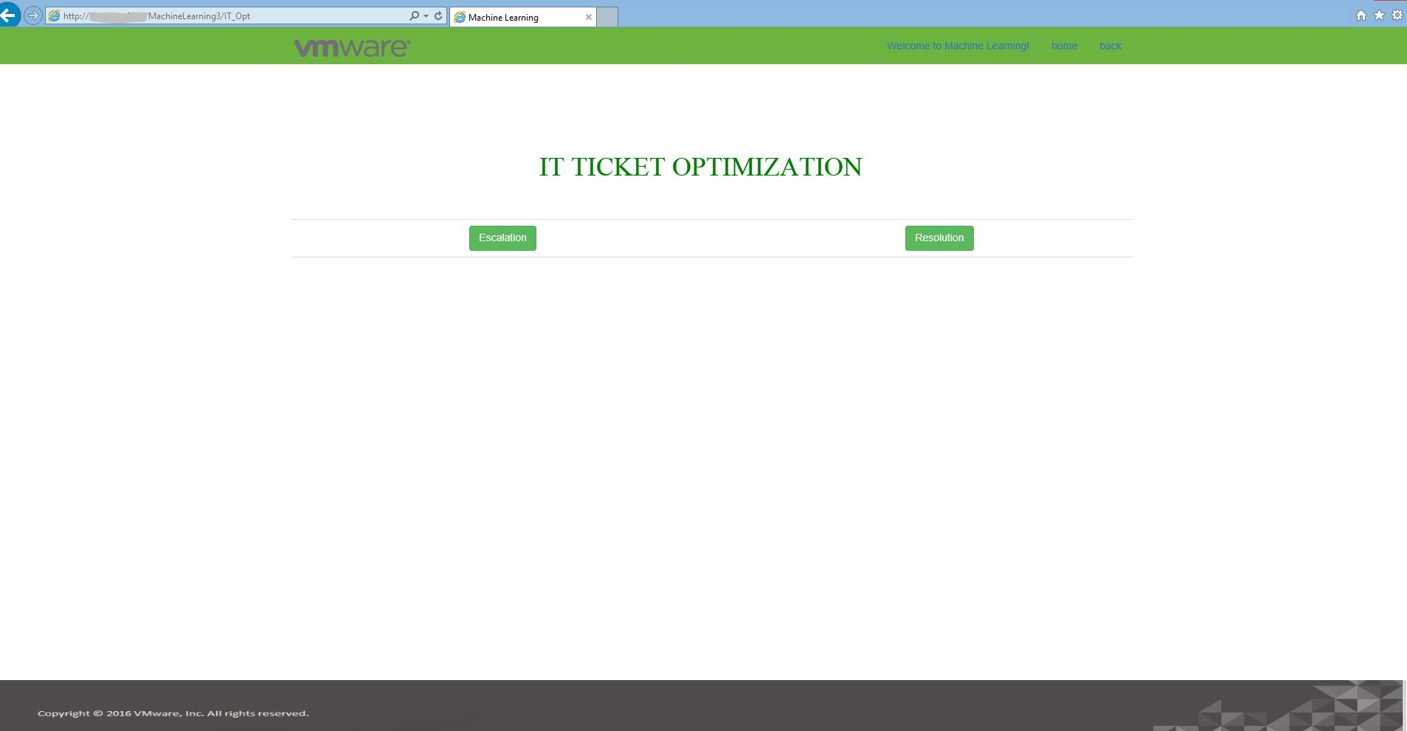

ESCALATION PREDICTION OUTPUT
9.3 HOME PAGE
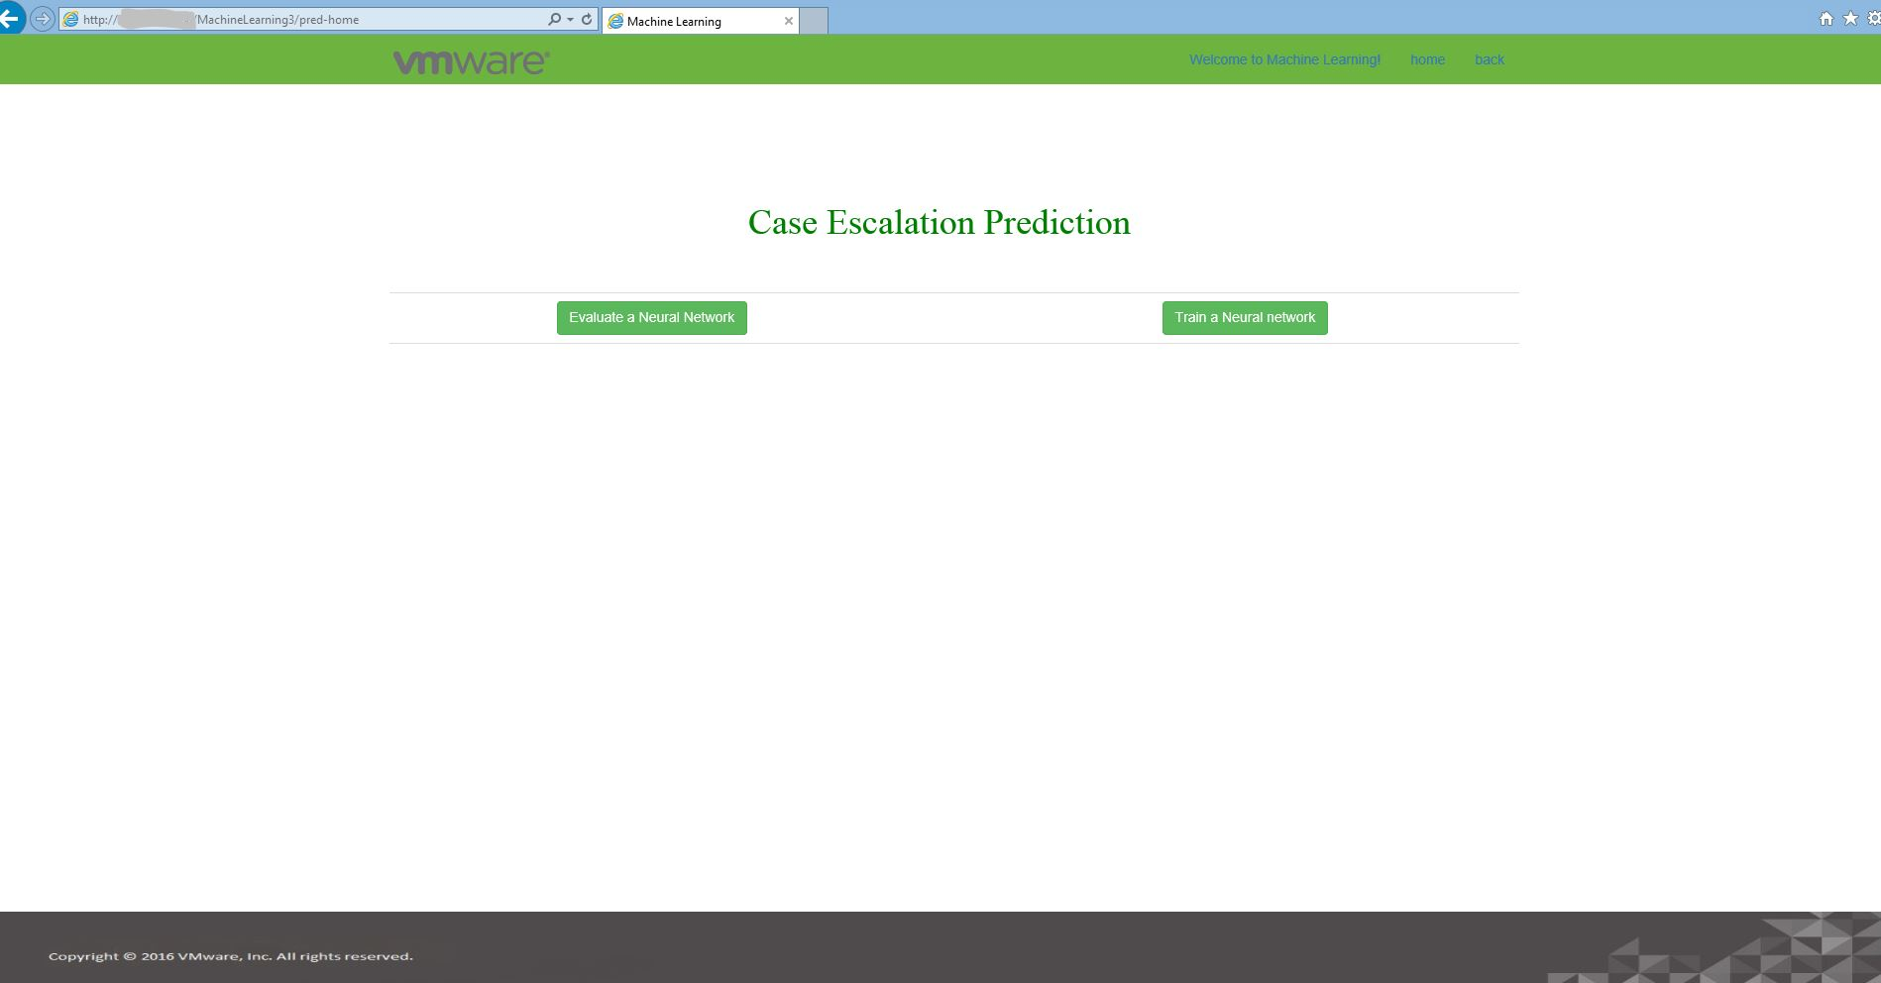

9.2 FILE UPLOAD PAGE(TRAINING)
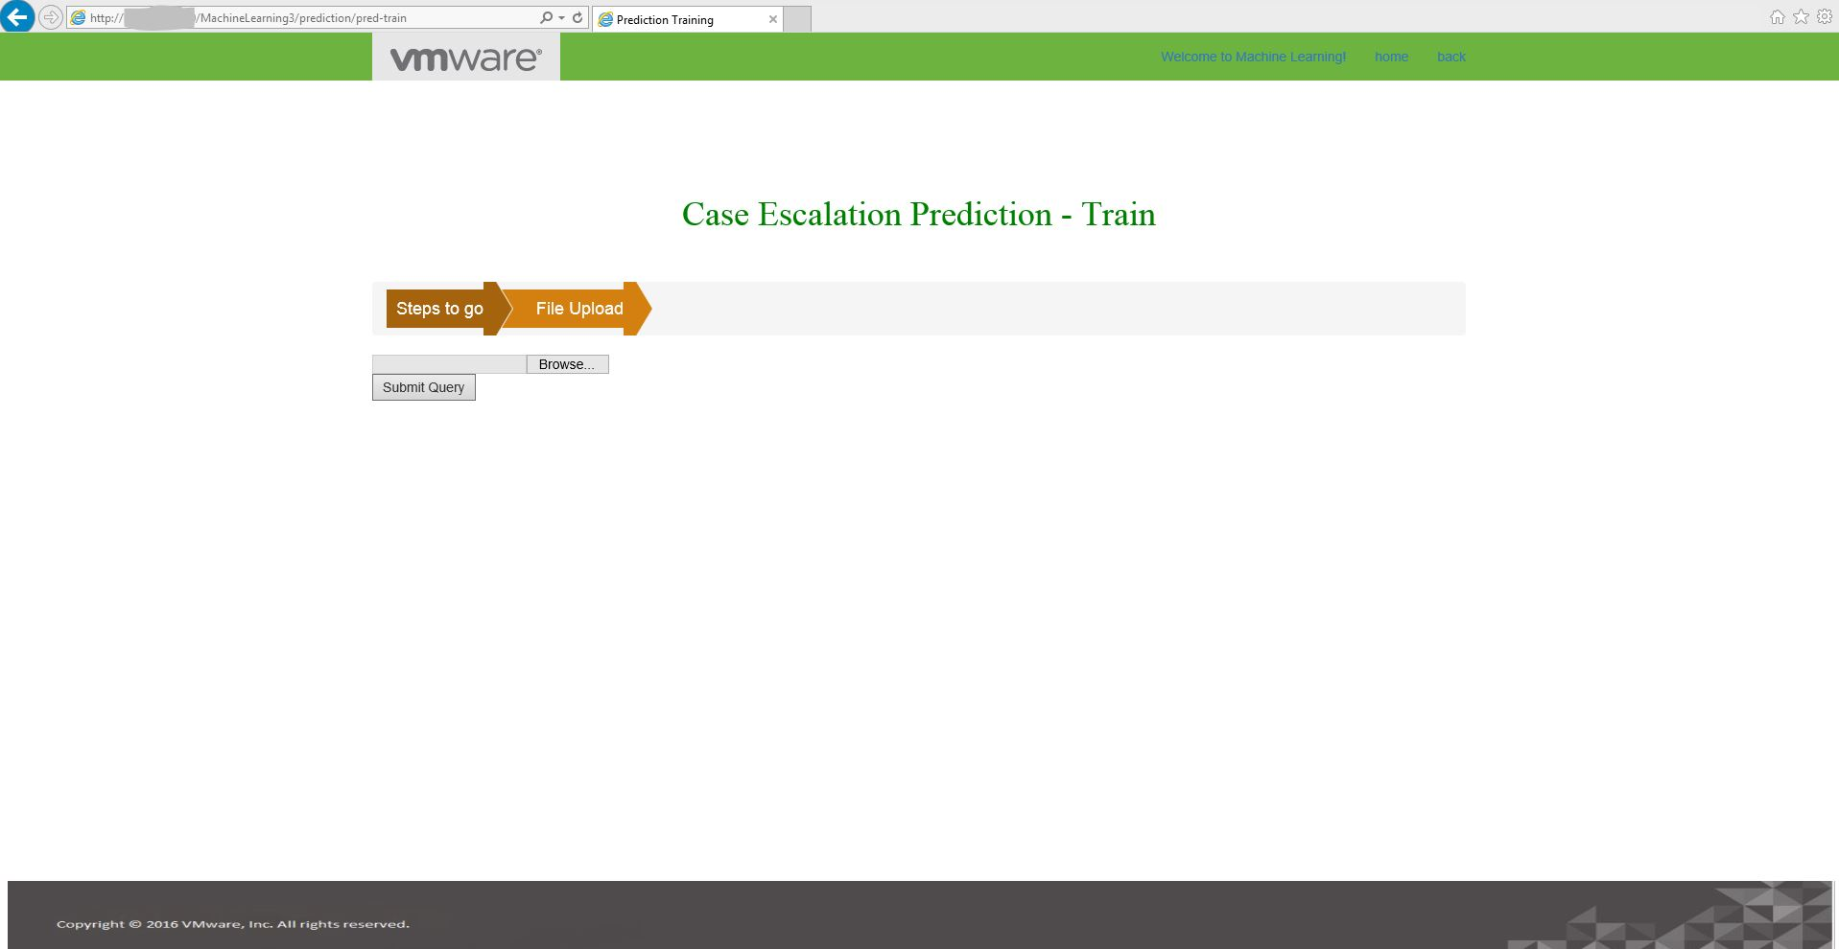

9.3 NORMALIZING FILE PAGE
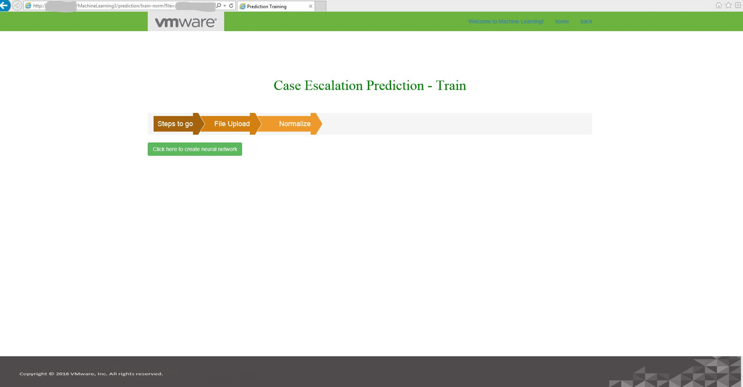

9.4 CREATING A NEURAL NETWORK PAGE
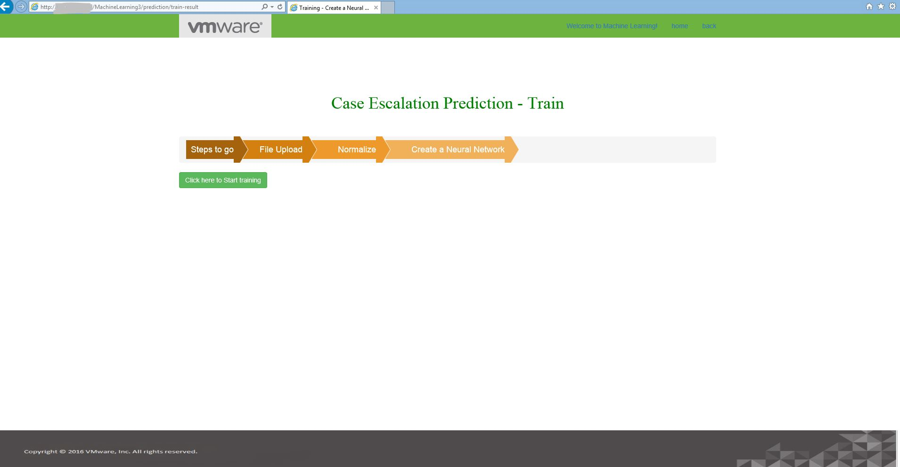

9.5 TRAIN ALERT PAGE
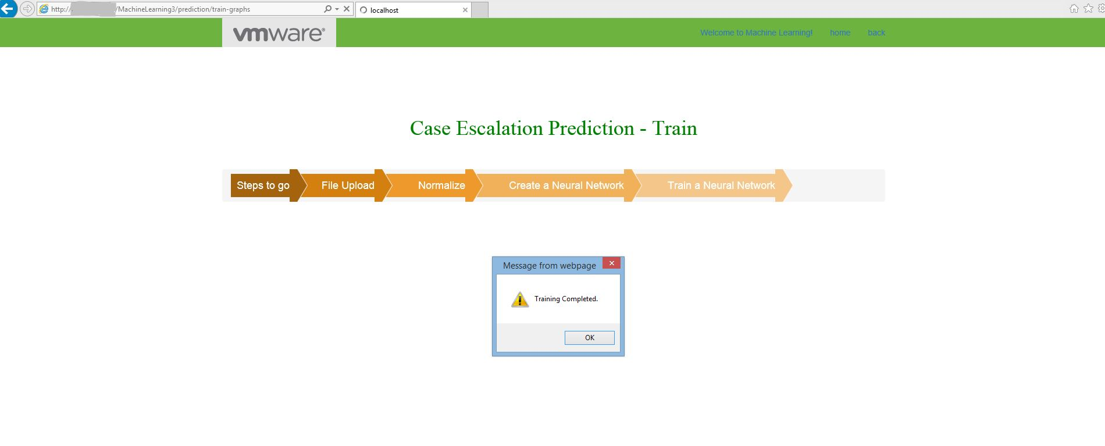

9.6 EVALUATE A NEURAL NETWORK PAGE
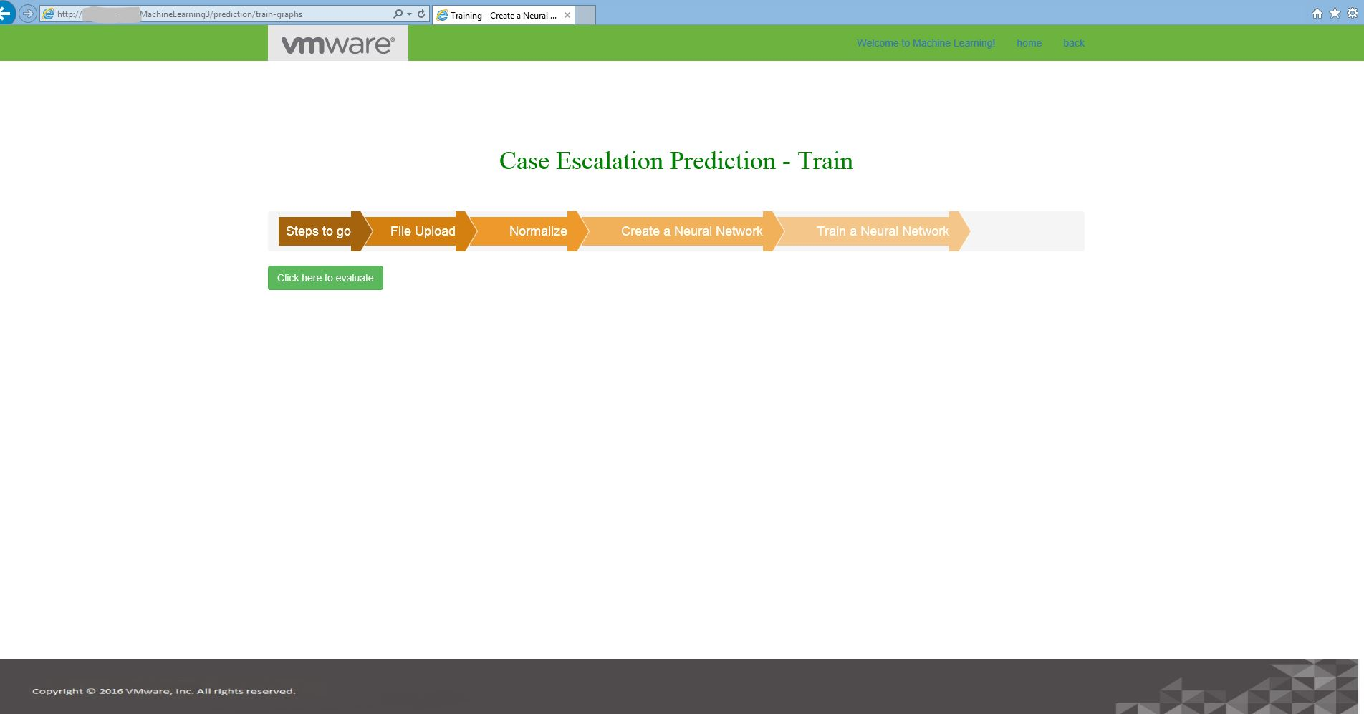

9.10 EVALUATION RESULT DOWNLOAD ALERT PAGE
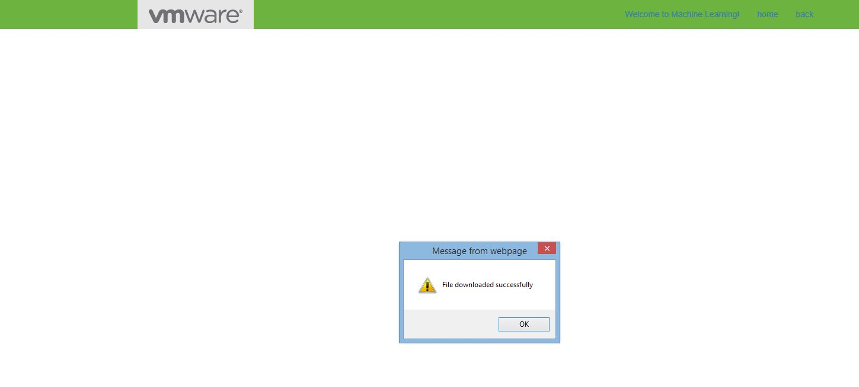

9.11 EVALUATION REPORT PAGE
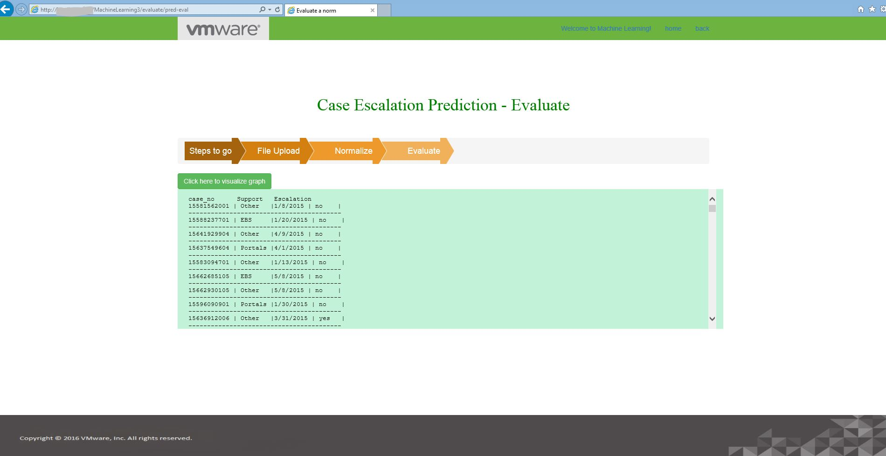

9.12 CHART

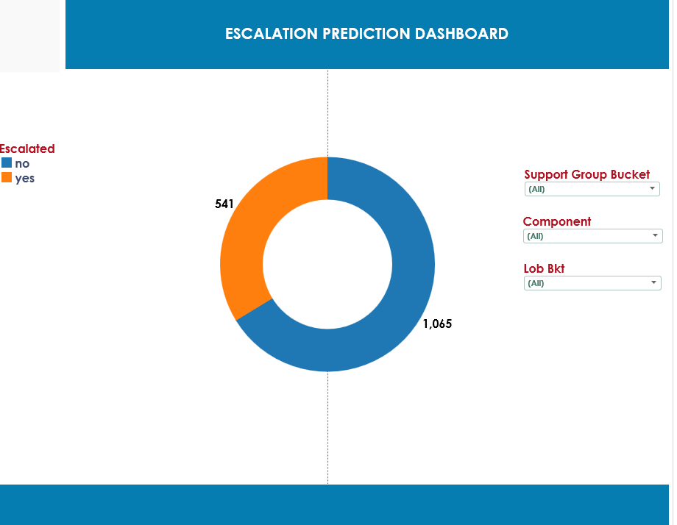

APPLYING FILTER
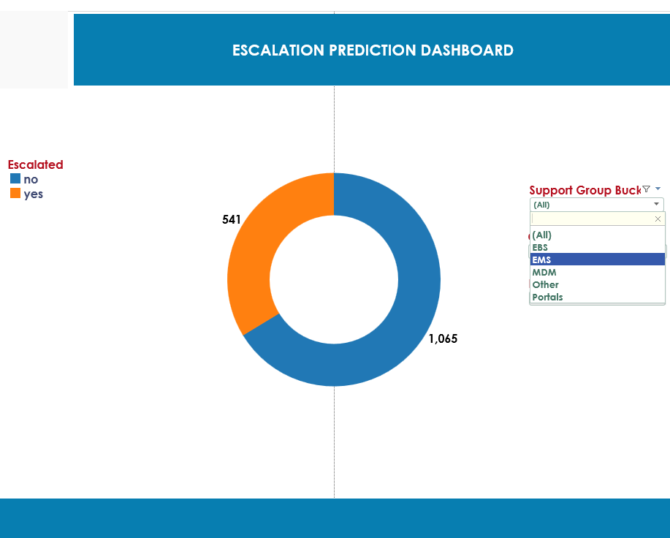

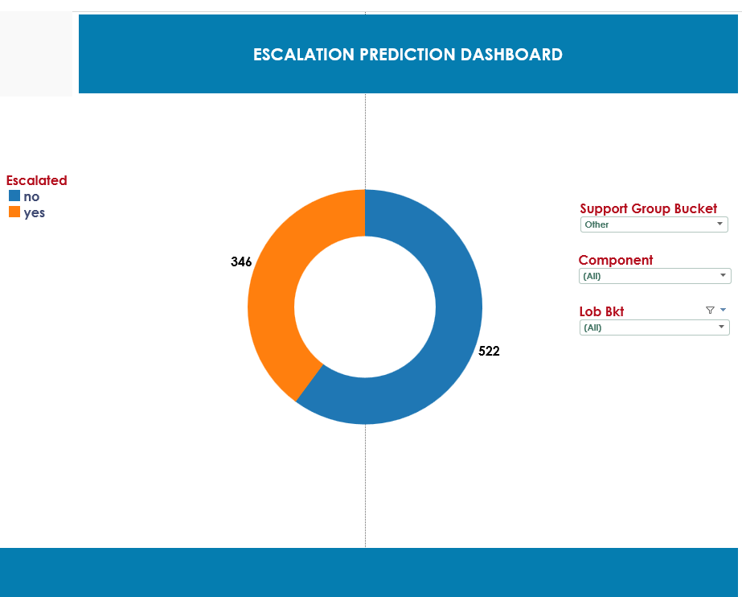

USECASE 2: RESOLUTION PREDICTION
9.13 HOME PAGE
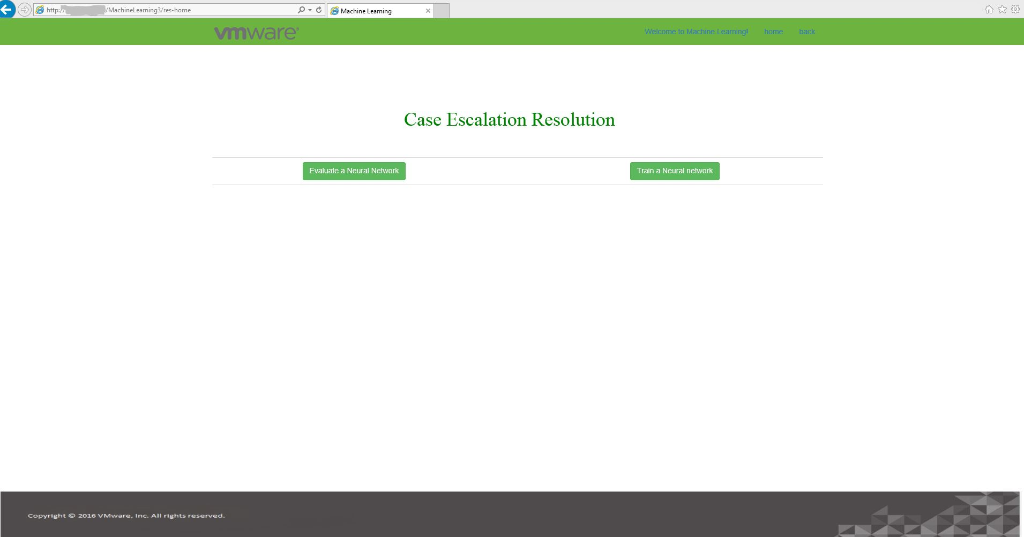

9.14 FILE UPLOAD PAGE
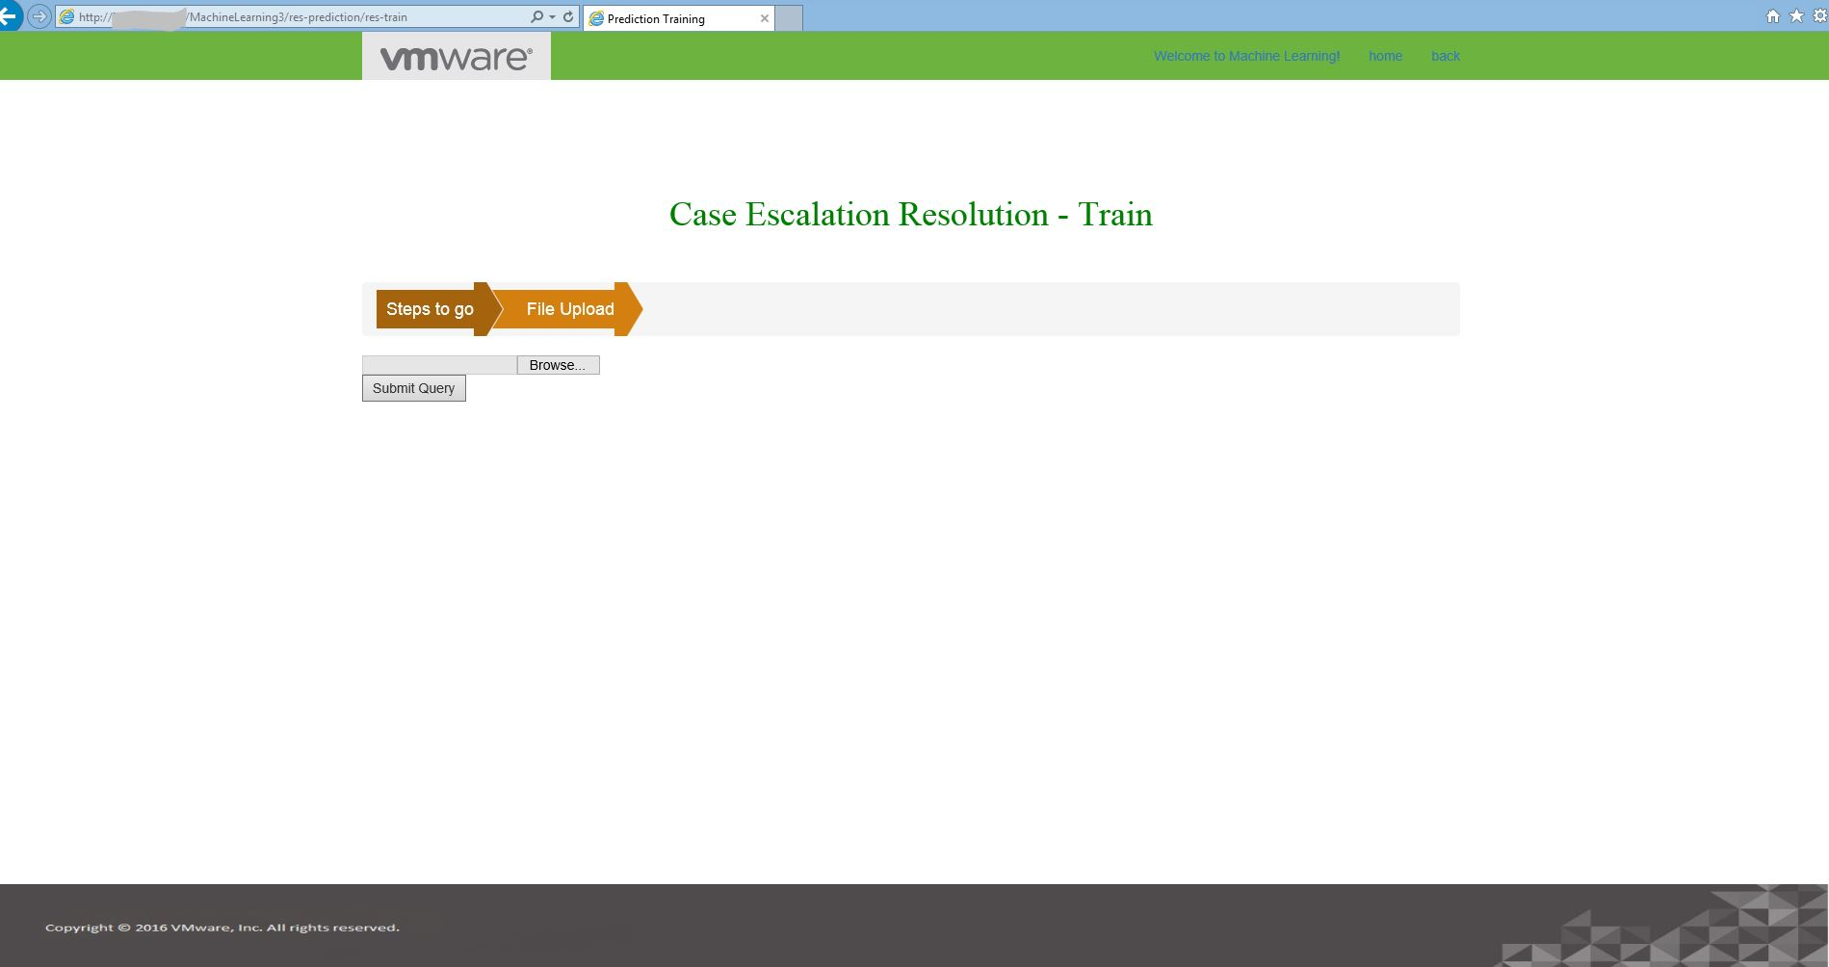

9.15 NORMALIZE PAGE
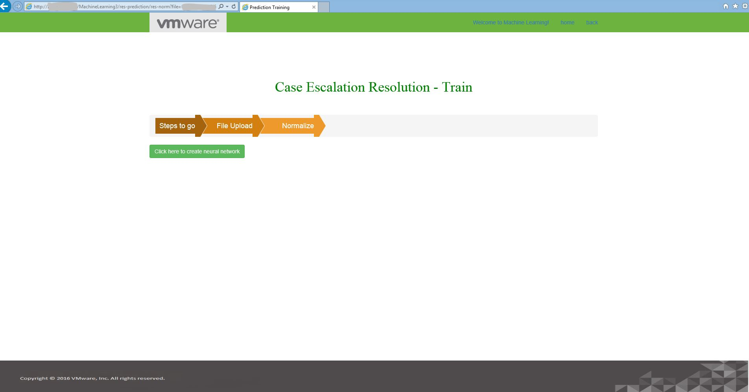

9.16 CREATING A NEURAL NETWORL PAGE
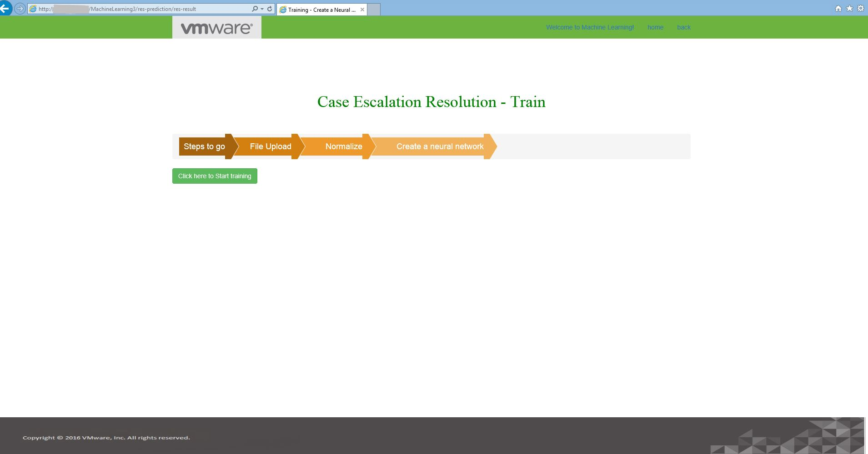

9.17 TRAINING COMPLETION ALERT
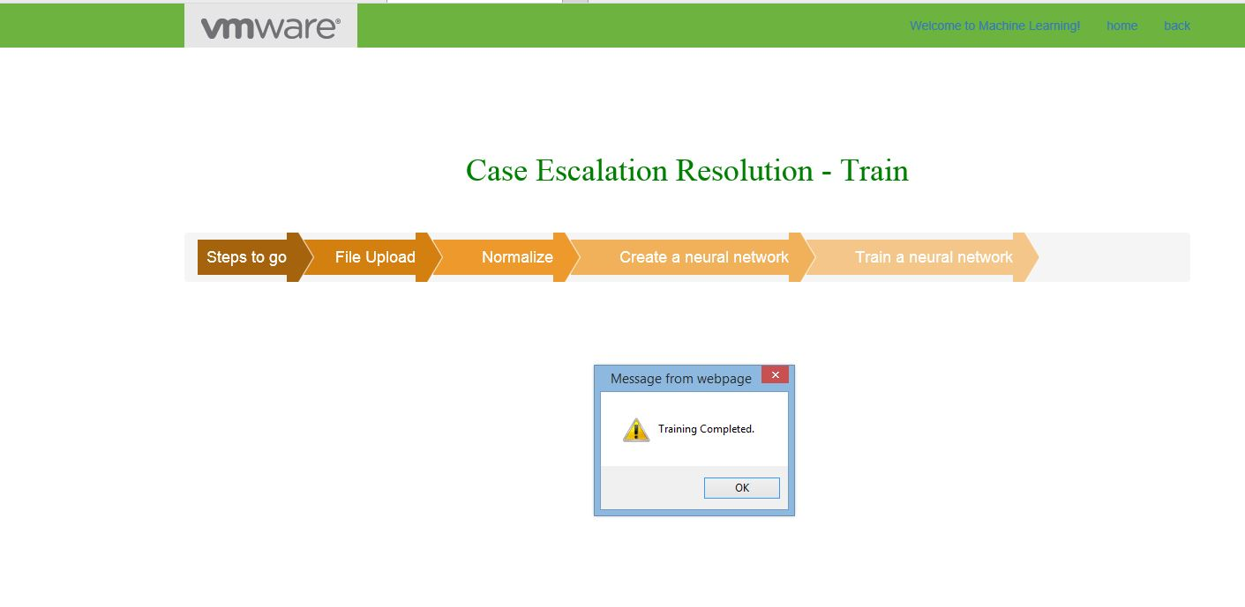

9.18 EVALUATION PAGE
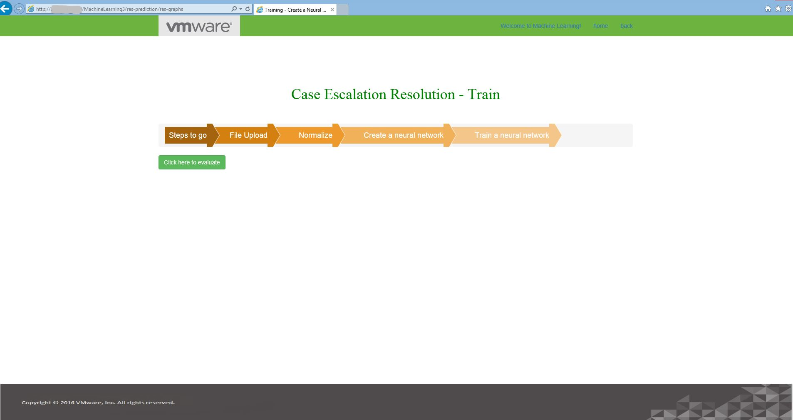

9.19 EVALUATE FILE UPLOAD PAGE
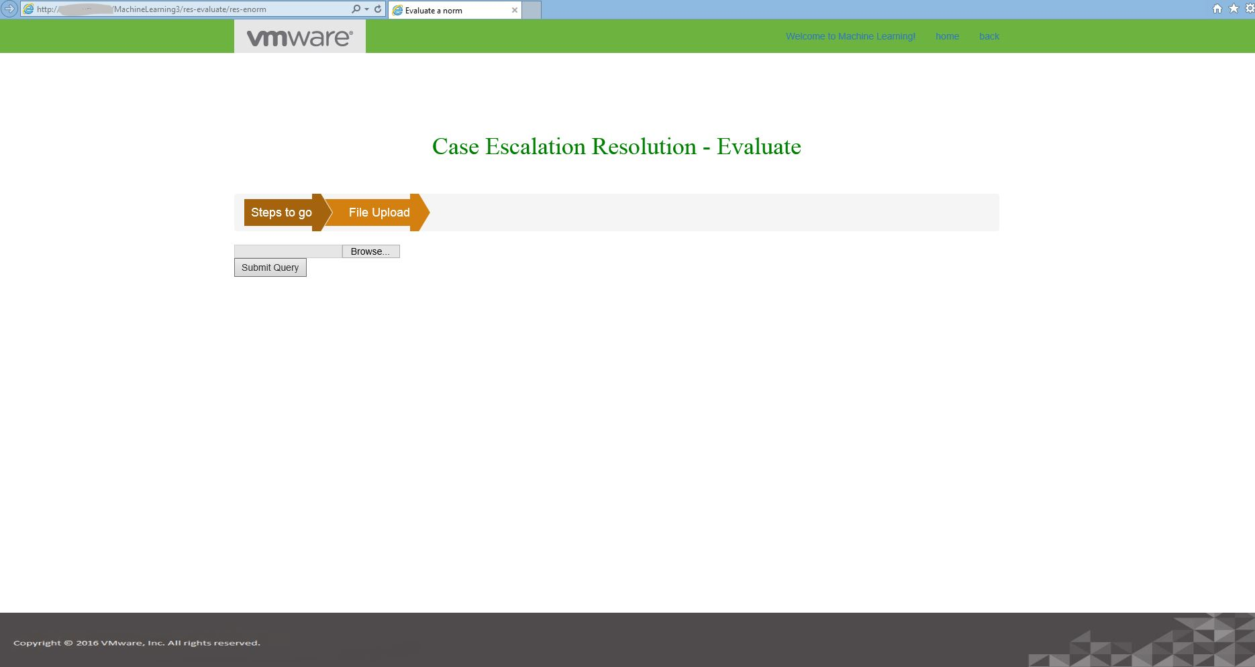

9.20 EVALUATION PAGE
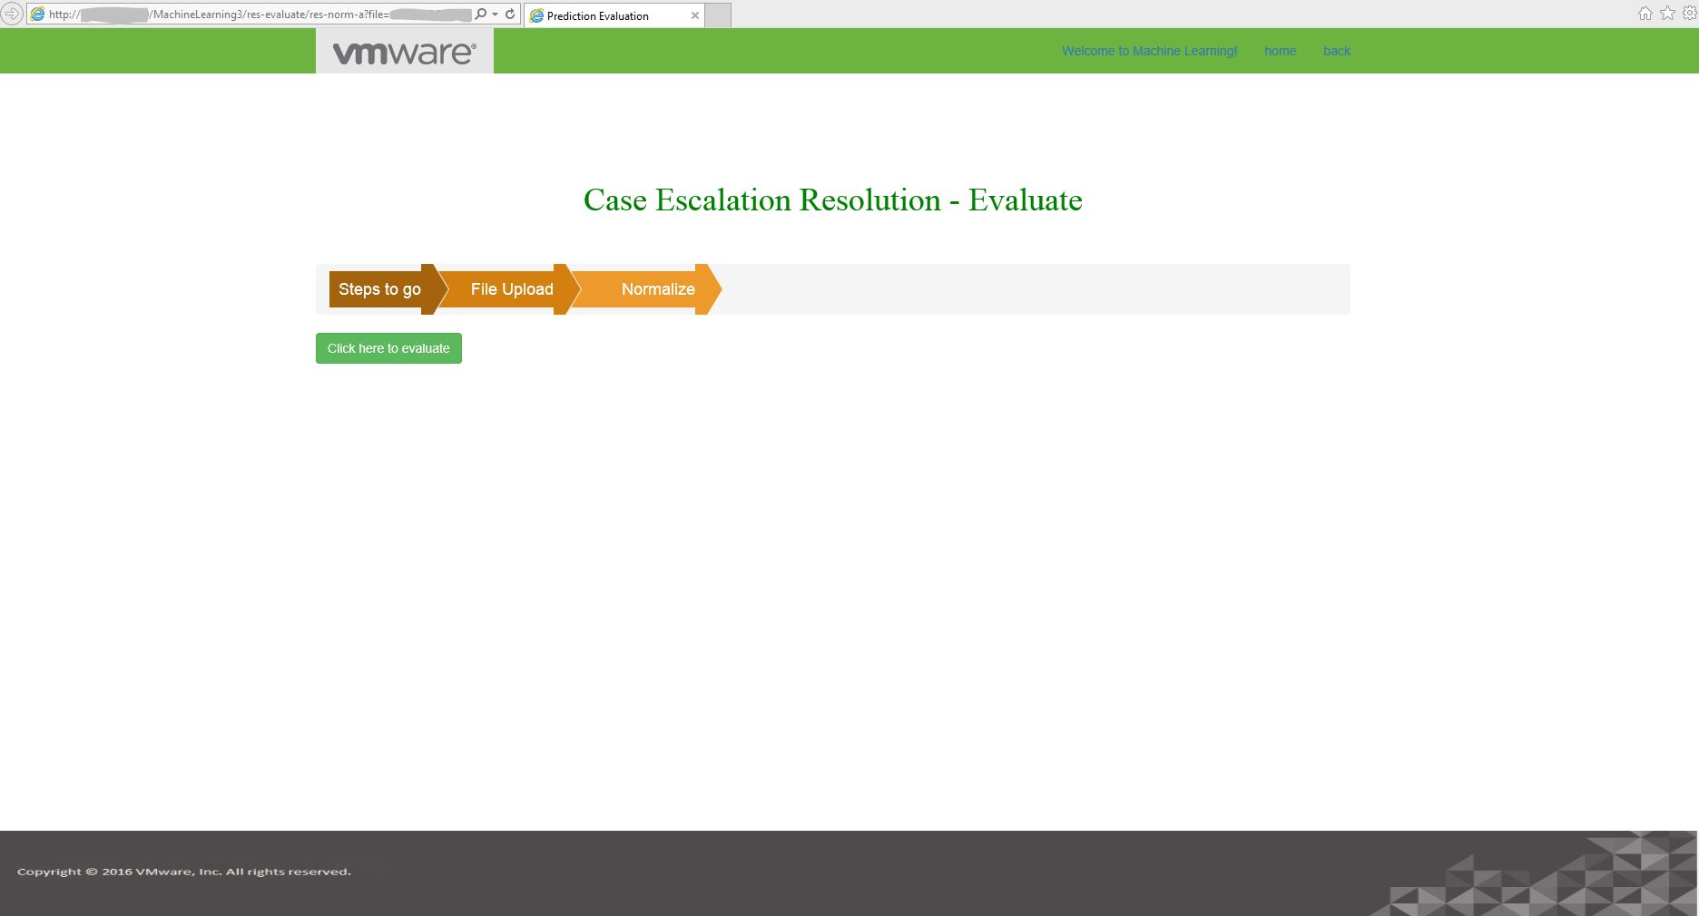

9.21 RESULT FILE DOWNLOAD ALERT PAGE

9.22 REPORT PAGE
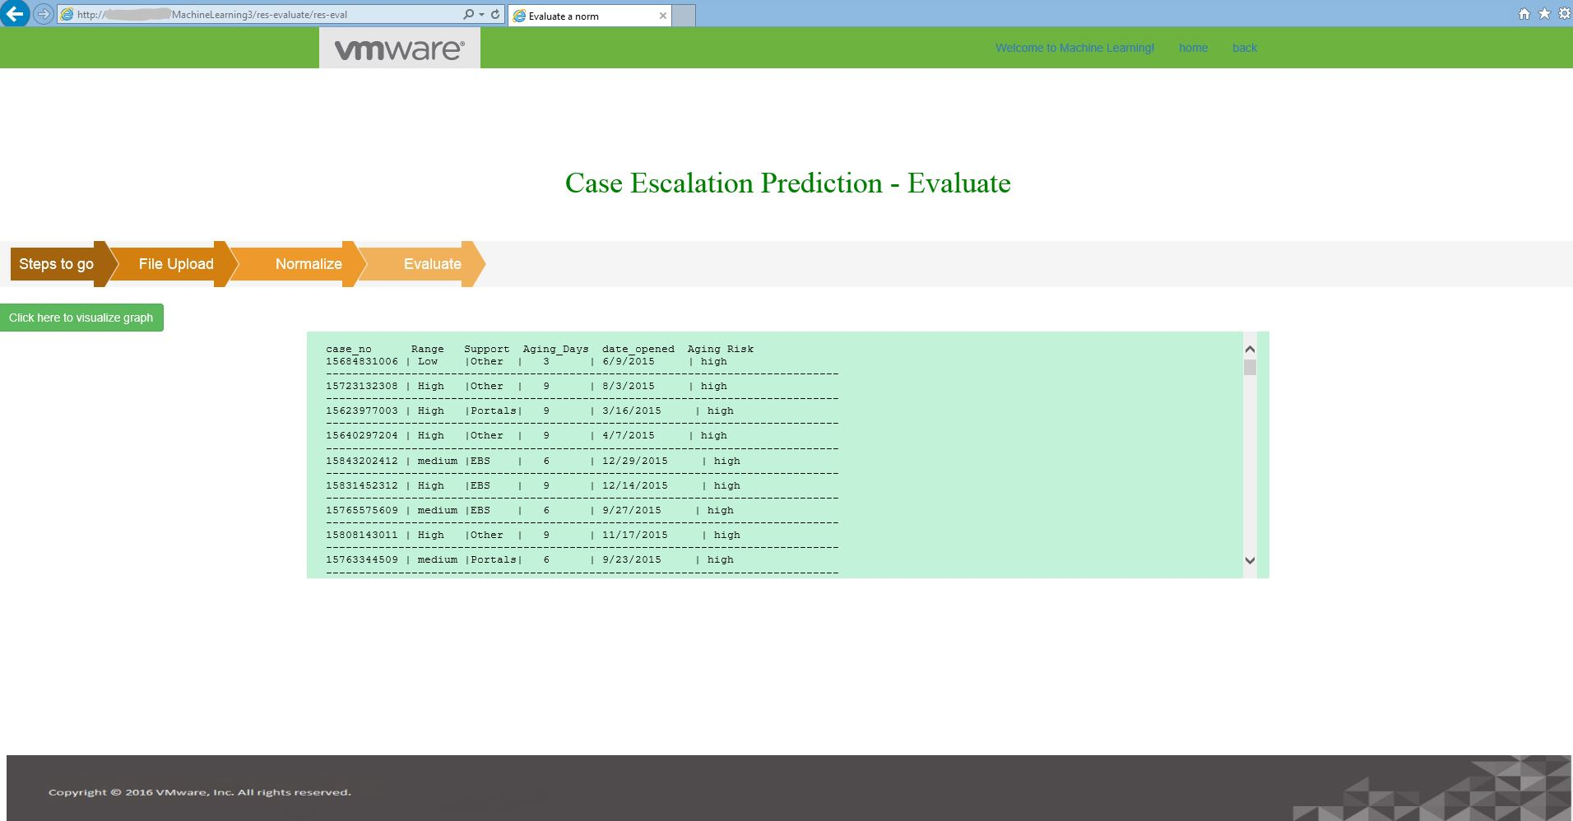
9.33 CHART

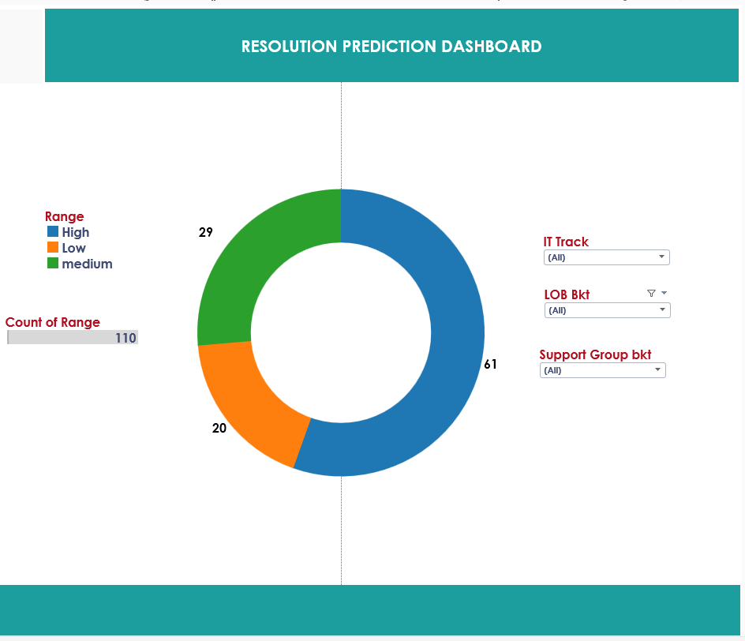

9.34 APPLYING FILTER
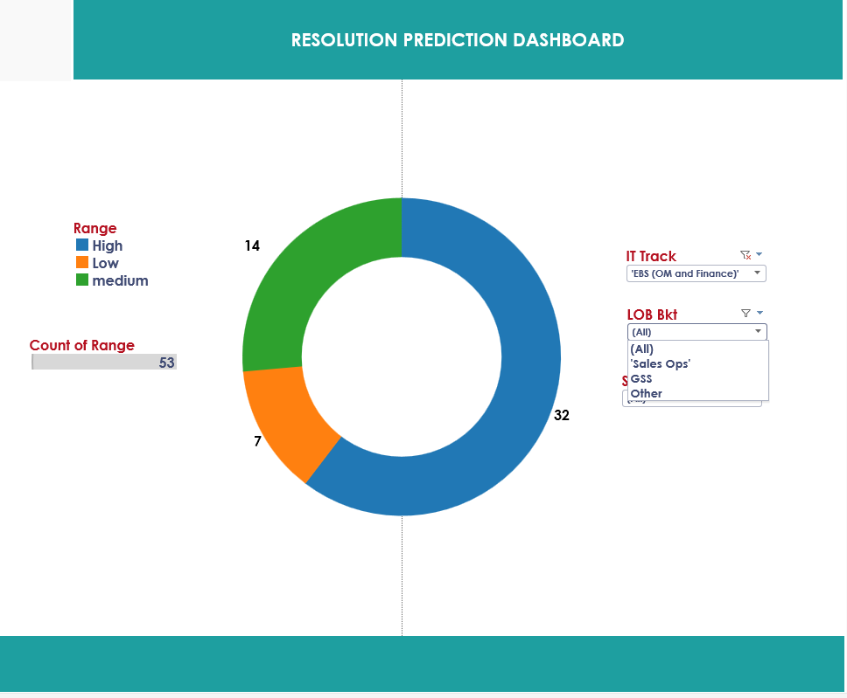
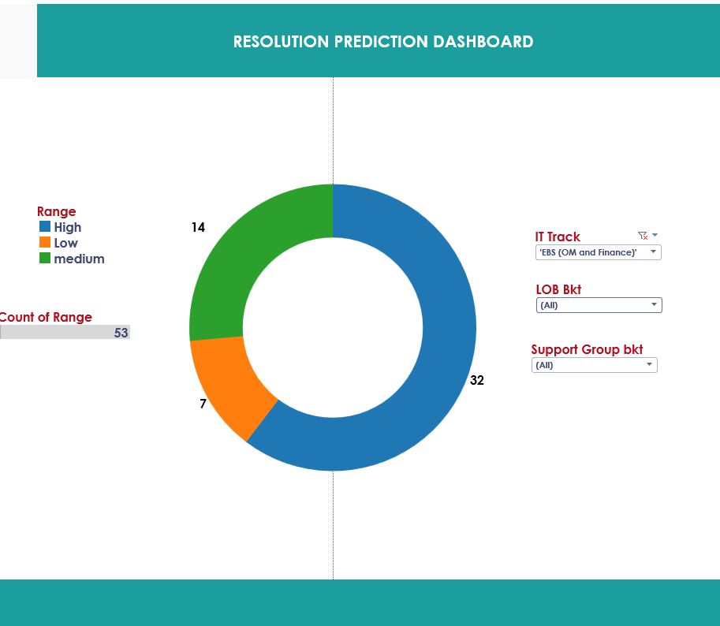

CHAPTER-10
CONCLUSION
10.1 CONCLUSION
Thus two models are built using Encog Machine Learning framework. The models can be used to estimate the severity of the issue and possibly the number of days within which the case has a chance to get escalated. This system can be deployed to resolve user issues as early as possible thereby improving customer satisfaction and product efficiency. In addition, this system can also be used as a form of a warning system. Manual intervention is henceforth reduced thereby reducing human errors.

10.2FUTURE PLANS
Another goal to be achieved in future is to create a Knowledge Base with a ranking system for all the members of each team in VMware so that a Ticket raised by a valuable customer reaches the highest ranking person of the appropriate team. The machine has to learn and rank employees based on his/her efficiency and speed of resolving tickets, experience etc. If the first ranking person is not available, the ticket goes to the next one in line and so on.

CHAPTER-11

REFERENCES

https://app.pluralsight.com/library/courses/advanced-machine-learning-encog/table-of-contents

https://app.pluralsight.com/library/courses/introduction-to-machine-learning-encog/table-of-contents

https://www.coursera.org/learn/machine-learning

http://www.heatonresearch.com/encog/

http://www.tutorialspoint.com/spring/spring_web_mvc_framework.htm

http://www.tutorialspoint.com/jsp/

http://www.tableau.com/learn/training

